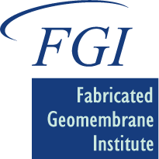

UNIVERSITY OF ILLINONIS
AT URBANA-CHAMPAIGN
Department of Civil and Environmental Engineering
Newmark Civil Engineering Laboratory, MC-250
205 North Mathews Avenue
Urbana, IL 61801-2352

FIRST FGI SHORT COURSE IN DENVER
By: Timothy D. Stark

The Fabricated Geomembrane Institute (FGI) held its first short course in Denver, Colorado at the Shearton Denver West Hotel and Conference Center. The short course was attend by sixty-six (66) people and was a great success. The course covered the design, specification, testing, manufacturing, fabrication, installation, inspection, and field testing of fabricated geomembranes in a variety of applications. The topics and speakers in the short course and photos from the short course are shown below:
FGI Introduction and Research - Tim Stark, U. of Illinois
Fabricated v. Rolled Geomembranes - Stan Slifer, Watersaver
Geomembrane Manufacturing - Gary Kolbasuk, Raven Industries; Bill Shehane, Seaman Corp.; Paul Yurcich, CGT
Fabrication & Installation - Stuart Lange, Lange Containment; John Heap, Colorado Lining; Stan Slifer, Watersaver
Leak Location Surveys - Daren Laine, Leak Location Services
Geomembrane Welding and Testing - Dave McLaury, DemTech
Floating Covers and Potable Water - Andrew Mills, Layfield Group
Canals, Decorative and Irrigation Ponds - John Heap, Colorado Lining; John Heathcote, Firestone
Wastewater Ponds - Trevor Arthurs, Engineered Coated Products/Intertapr
Secondary Containment - Stuart Lange, Lange Containment; Ray Peebles, Cooley Group
Case Histories – Thiel, Mills, Lange, Shehane, Slifer, Heap, Eichelberger, Heap,
Summary - Tim Stark, U. of Illinois

The following are photographs of the short course activities.
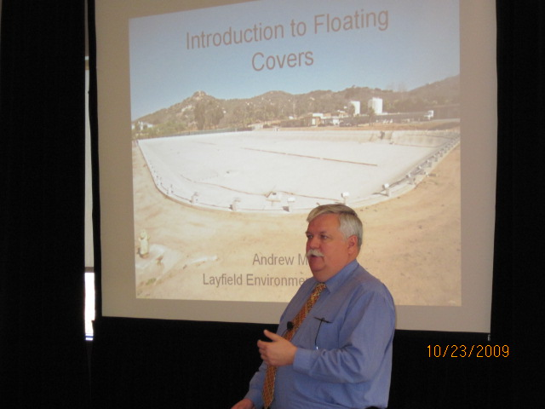
Andrew Mills presenting floating covers

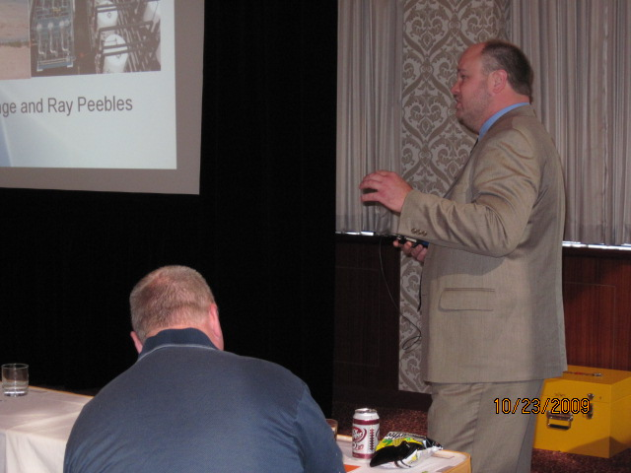
Ray Peebles presenting secondary containment

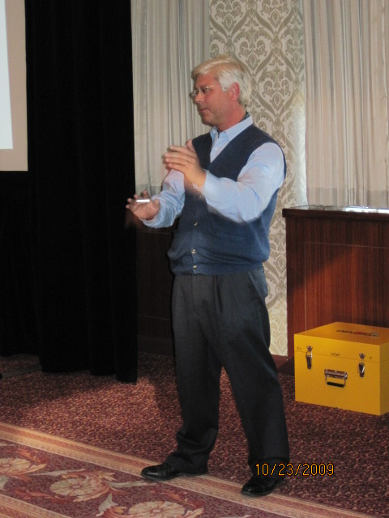
Rick Thiel presenting case histories on EIA geomembranes

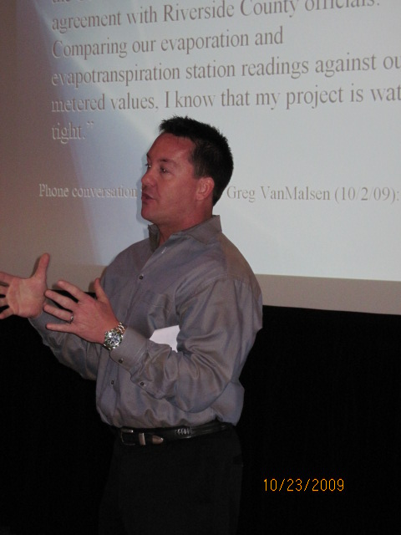
Stan Slifer presenting the Shadow Lakes Estates case history
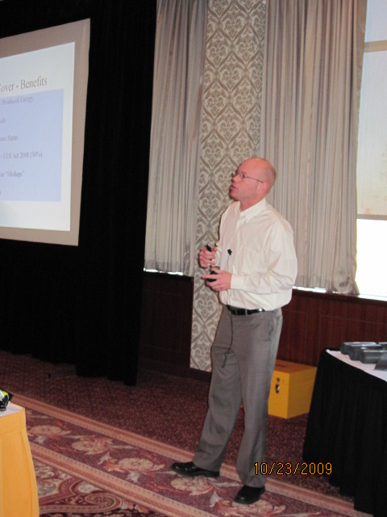
Chris Eichelberger presenting a solar landfill cover case history

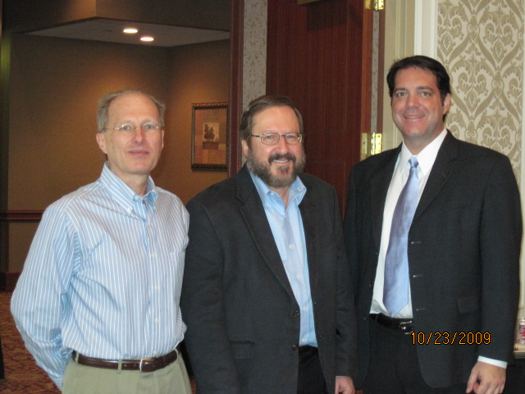
Speakers Daren Laine, Gary Kolbasuk, and Sam Allen (left to right) during a break

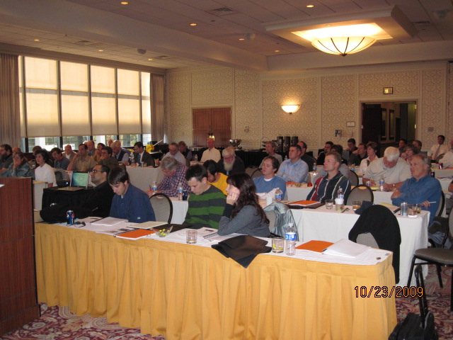
Sixty-six attendees listening to a presentation

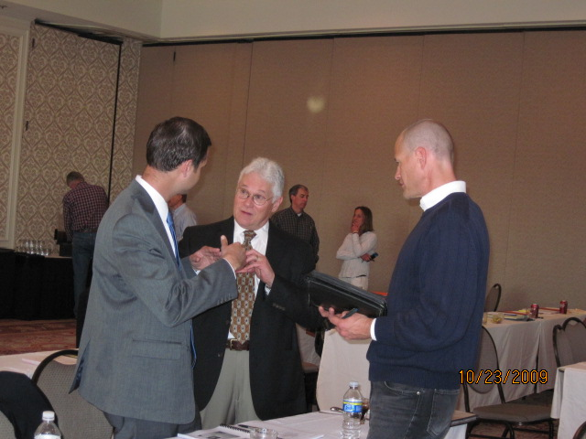
Jermiah Boorsma, Stuart Lange (speaker), and Duff Simbeck (left to right) chatting during a break
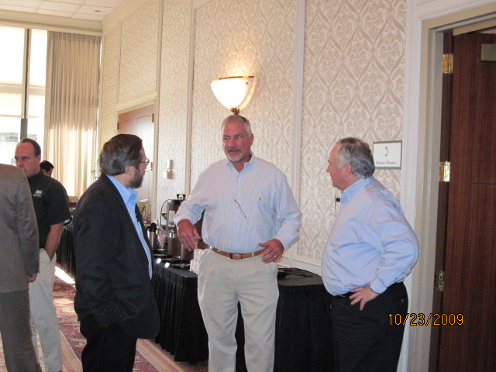
Gary Kolbasuk (speaker), John Heap (spearker), and Paul Oliveira (left to right) chatting during a break

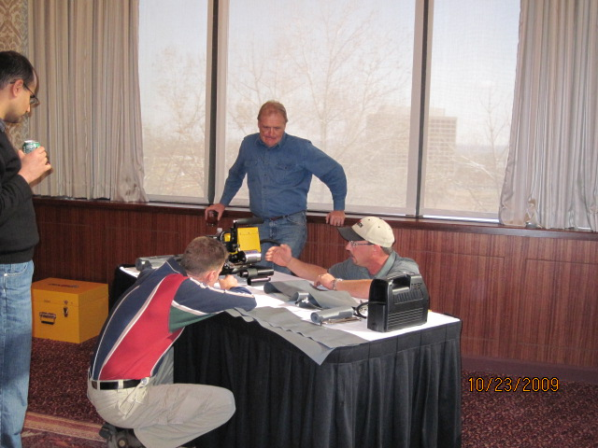
Dave McLaury (in hat) explaining wedge welding to attendees

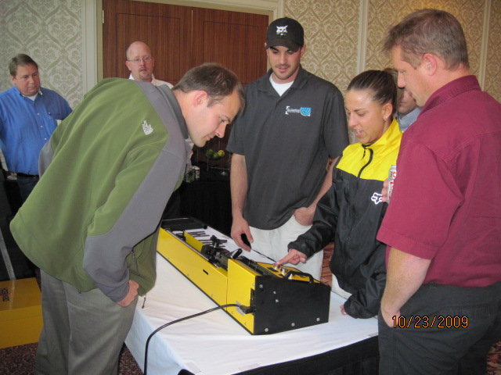
Attendee Melissa Hinman learning how to operate a tensiometer during the demonstration session

The FGI is dedicated to advancing the use of fabricated geomembranes through education, research, and technology transfer. The FGI is a consortium of manufacturers, fabricators/installers, designers, regulators, and material suppliers of fabricated geomembranes. For more information on the FGI, please visit www.fabricatedgeomembrane.com

